**How to create Machine**

Step 1: Login with control room manager & navigate into create Client menu, In create Client page is contain create client button & view of the clients data.

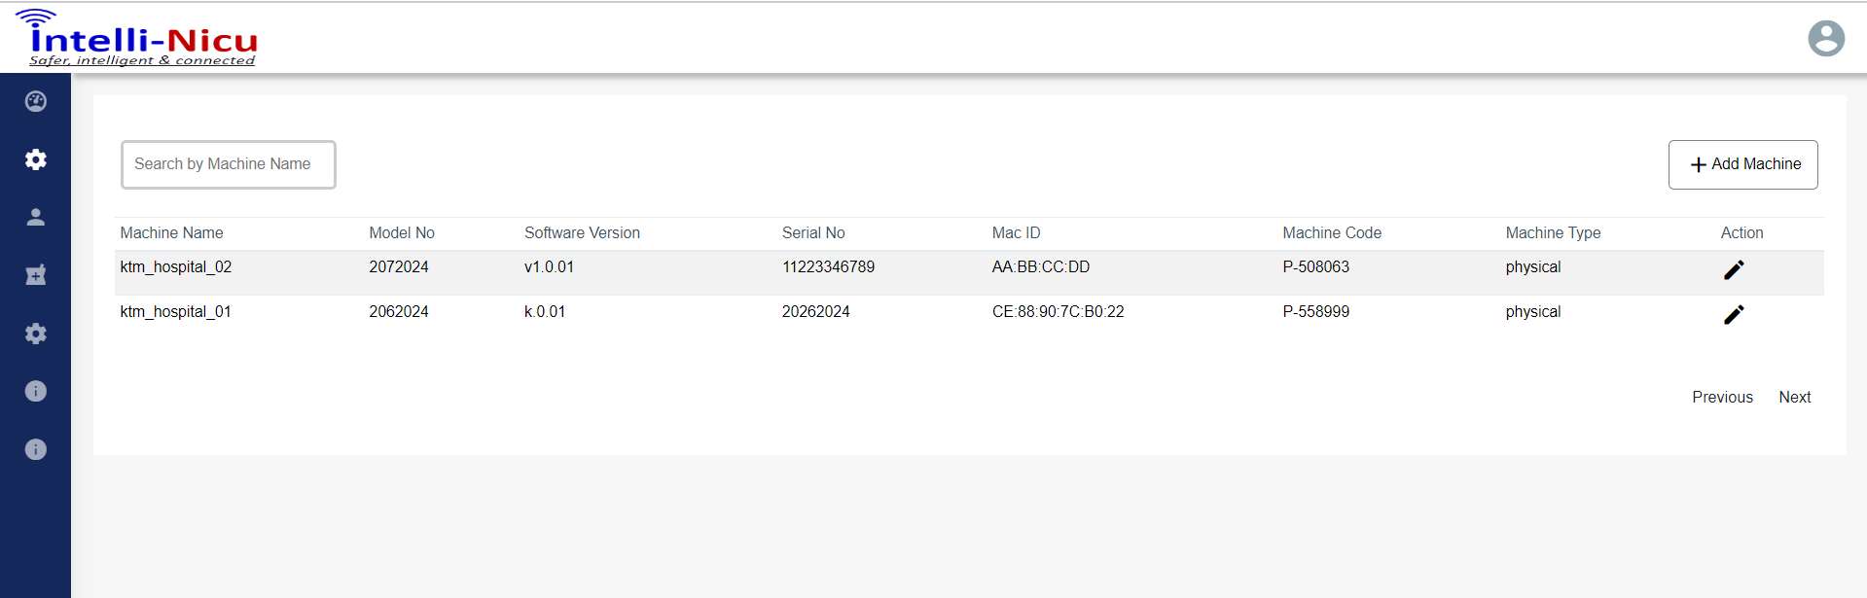

Step 2: after clicking the create machine button, one popup open with create machine form & it contain (Machine type, machine name, model no, software version, serial no,MacID)

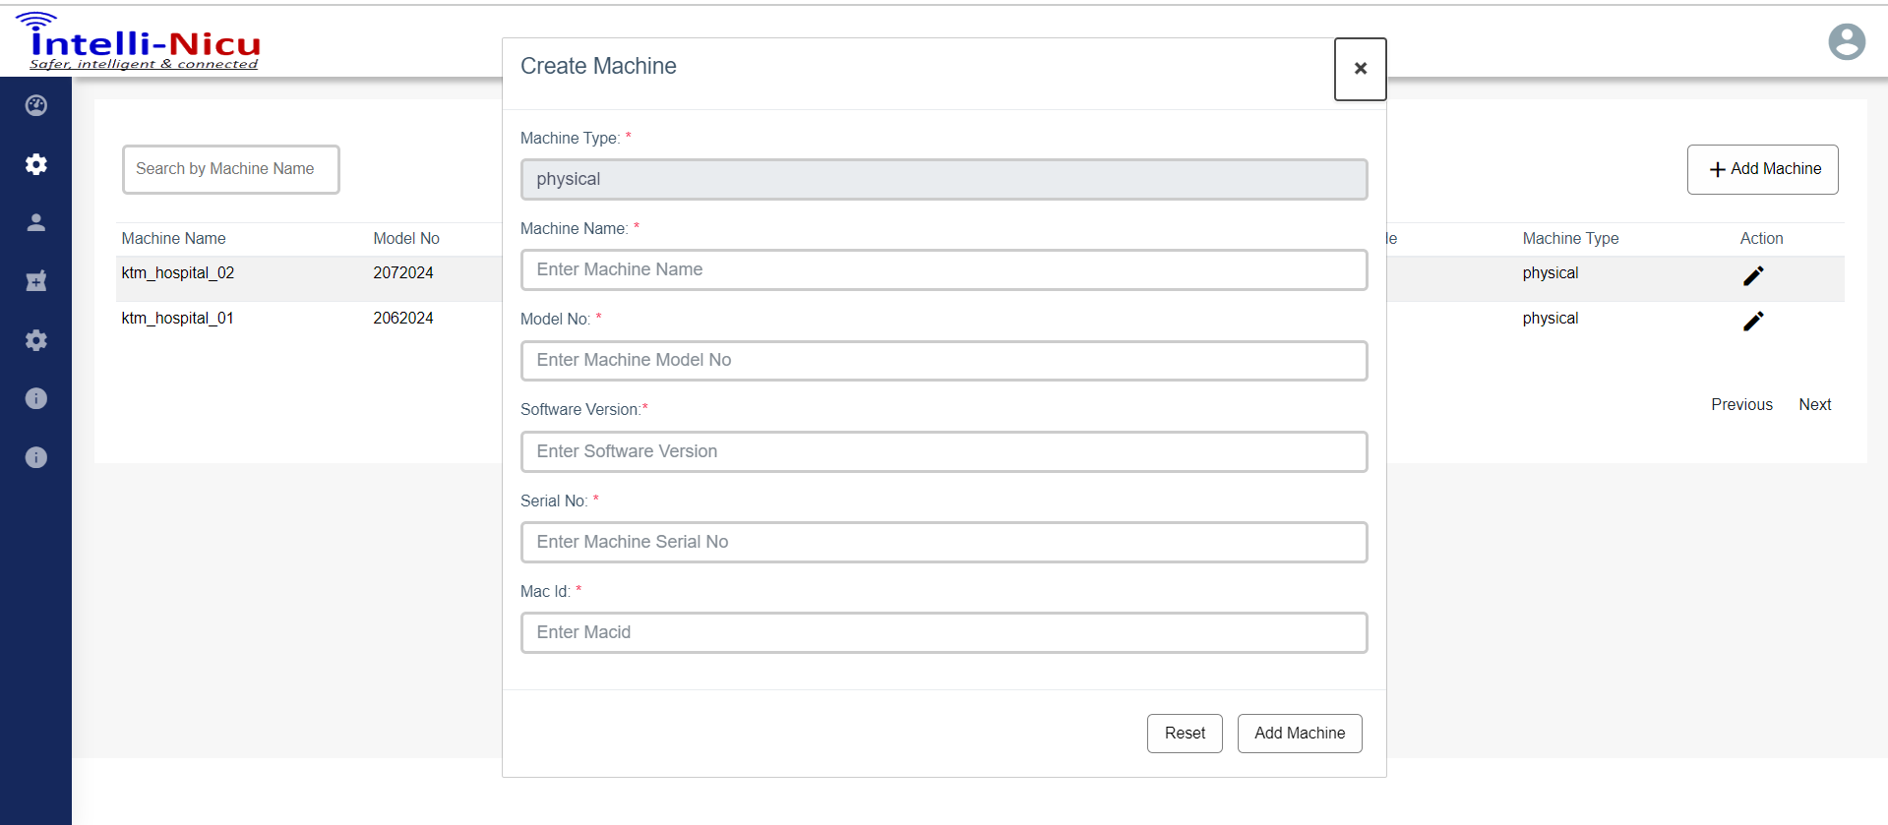

Verify the create machine API

Conditional cluses :

1. If MacID is present in system then server send the below response

Response : res(commanfunction.response_API([], false, "s_432", [], 0));

Description:

1. Validating the usermasterid from user master table & checking the prefix of ‘CSM’ is present in the user master table, if exists the control structure move for a further operation otherwise server send the below response

res(commanfunction.response_API([], false, "s_405", [], 0));

1. Validating the machineserialno from machinemaster, if machineserialno is equal to 0 , it means machineserialno is not present in the database, The next line we will check database count with equal to 0 , if condition is meet control structure move forward to for creating new machine with available status.
2. If all thing are going good server send the below response.

res(commanfunction.response_API([], true, "s_402", [], 0));